CS 3050 Homework # 4. Name :Hamza Thabit

Submitted to Blackboard, due at 11:59pm on March 26, 2019.

1. For the following Trees, tell whether they are valid Red and Black trees or not. If not, point out which property the tree violates. The nil leaves are not drawn for convenience. (Please note that a node with double circles indicates black, and a node with single circle indicates red)

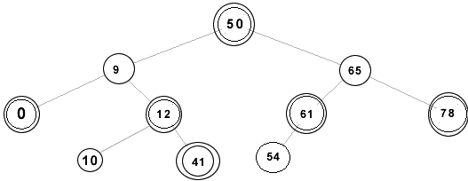
(i)

Node 41 vilate the path rule. The noly node that takes 3 balck nodes to reach
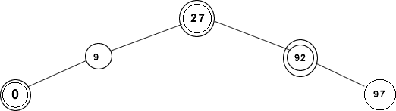
(ii).

Valid

(iii).
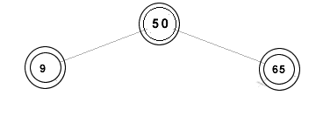

valid

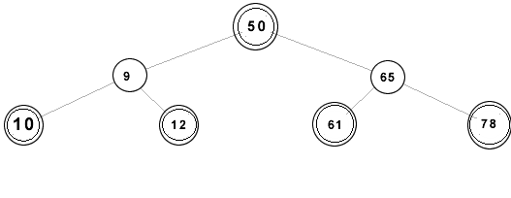
(iv).

Valid

2. Write pseudocode for RIGHT-ROTATE by modifying the algorithm in Figure 13.3 of the textbook.

1 y D x:left // set y
2 x:left D y:right // turn y’s right subtree into x’s left subtree
3 if y:right ≠ T:nil
4 y:right:p D x
5 y:p D x:p // link x’s parent to y
6 if x:p == T:nil
7 T:root D y
8 elseif x == x:p: right
9 x:p: right D y
10 else x:p:left D y
11 y:right D x // put x on y’s right
12 x:p D y
3. Draw the red-black trees that result after successively inserting the keys P, S, E, U, D, O, C into an initially empty red-black tree. The order of letters are alphabetical. You may use filled circles to indicate black and unfilled circles to indicate red.

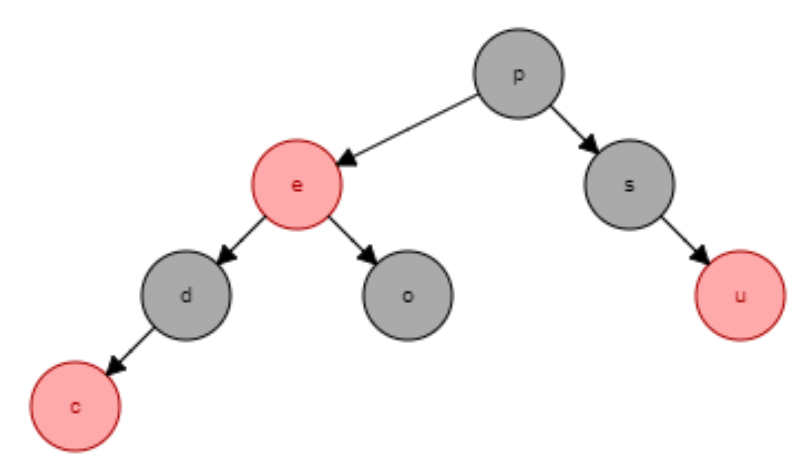

4. For the following order-statistics tree T, (1) show how OS-SELECT (T, 9) operates; (2) show how OS-RANK(T, 35) operates.

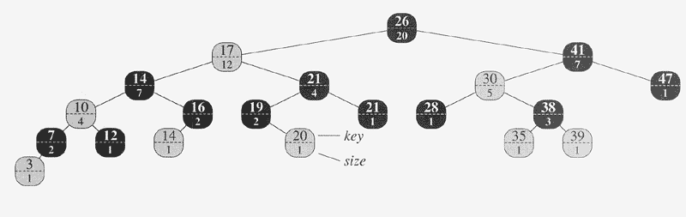

OS-SELECT(x, i )
1 r = x:left:size + 1
2 if i == r
3 return x
4 elseif i < r
5 return OS-SELECT(x. left, i)
6 else return OS-SELECT(x.right, i – r)

Itiration | i | r
1 (26) | 9 | 13
2 (17) | 9 | 8
3 (21) | 8-8 = 1 | 3
4 (19) | 1 | 1

OS-RANK(T, x)
1 r = x.lef:size + 1
2 y = x
3 while y ≠ T.root
4 If y == y.p.right
5 r = r + y.p.left.size + 1
6 y = y.p
7 return r
Iteration | R | Y
1 | 1 | 35
2 | 1 | 38
3 | 3 | 30
4 | 3 | 41
5 | 16 | 26

5. Given an interval tree T and an interval i , describe how to list all intervals in T that overlap i efficiently using pseudo code. [Hint: There are multiple ways to solve it. One way is to check both right and left subtrees from the root iteratively.

INTERVAL-SEARCH(T, i)
1 x = T.root
2 while x ≠ T.nil and i does not overlap x.int
3 if x.left ≠ T.nil and x.left.max ≥ i.low
4 x = x.left
5 else x = x.right
6 return x
List // create list of intervals.
While (i.min < i.max){
Interval x = (I.min, I.min)
List.push (INTERVAL-SEARCH(T, x))
i.min ++
}

